**CS306ES: ANALOG AND DIGITAL ELECTRONICS LAB**

**B.Tech. II Year I Sem. L T/P/D C**

**0 0/ 2/ 0 1**

**Course Objectives**

**•** To introduce components such as diodes, BJTs and FETs.

**•** To know the applications of components.

**•** To give understanding of various types of amplifier circuits

**•** To learn basic techniques for the design of digital circuits and fundamental concepts used in

the design of digital systems.

**•** To understand the concepts of combinational logic circuits and sequential circuits.

**Course Outcomes:** Upon completion of the Course, the students will be able to:

**•** Know the characteristics of various components.

**•** Understand the utilization of components.

**•** Design and analyze small signal amplifier circuits.

**•** Postulates of Boolean algebra and to minimize combinational functions

**•** Design and analyze combinational and sequential circuits

**•** Known about the logic families and realization of logic gates.

**LIST OF EXPERIMENTS**

1. Full Wave Rectifier with & without filters

2. Common Emitter Amplifier Characteristics

3. Common Base Amplifier Characteristics

4. Common Source amplifier Characteristics

5. Measurement of h-parameters of transistor in CB, CE, CC configurations

6. Input and Output characteristics of FET in CS configuration

7. Realization of Boolean Expressions using Gates

8. Design and realization logic gates using universal gates

9. Generation of clock using NAND / NOR gates

10. Design a 4 – bit Adder / Subtractor

11. Design and realization a Synchronous and Asynchronous counter using flip-flops

12. Realization of logic gates using DTL, TTL, ECL, etc.

**STUDY OF BASIC ELECTRONIC COMPONENTS**

**1.1. RESISTOR**

A **Resistor** is a [passive](http://en.wikipedia.org/wiki/Passivity_%28engineering%29) [two-terminal](http://en.wikipedia.org/wiki/Terminal_%28electronics%29) [electrical component](http://en.wikipedia.org/wiki/Electronic_component) that implements [electrical](http://en.wikipedia.org/wiki/Electrical_resistance) [resistance](http://en.wikipedia.org/wiki/Electrical_resistance) as a circuit element. The [current](http://en.wikipedia.org/wiki/Electric_current) through a resistor is in [direct proportion](http://en.wikipedia.org/wiki/Direct_proportion) to the [voltage](http://en.wikipedia.org/wiki/Voltage) across the resistor's terminals. This relationship is represented by [Ohm's law:](http://en.wikipedia.org/wiki/Ohm%27s_law)

I=V/R

Where I is the current through the [conductor](http://en.wikipedia.org/wiki/Electrical_conductor) in units of [amperes,](http://en.wikipedia.org/wiki/Amperes) V is the potential difference measured across the conductor in units of [volts,](http://en.wikipedia.org/wiki/Volts) and R is the resistance of the conductor in units of [ohms.](http://en.wikipedia.org/wiki/Ohm)

The ratio of the voltage applied across a resistor's terminals to the intensity of current in the circuit is called its resistance, and this can be assumed to be a constant (independent of the voltage) for ordinary resistors working within their ratings.

**1.2. COLOUR CODING OF RESISTOR**

Colour Codes are used to identify the value of resistor. The numbers to the Colour are identified in the following sequence which is remembered as **BBROY GREAT** **BRITAN VERY GOOD WIFE (BBROYGBVGW)** and their assignment is listed infollowing table.

|  |  |  |  |  |  |  |  |  |  |
| --- | --- | --- | --- | --- | --- | --- | --- | --- | --- |
| **Black** | **Brown** | **Red** | **Orange** | **Yellow** | **Green** | **Blue** | **Violet** | **Grey** | **White** |
| **0** | **1** | **2** | **3** | **4** | **5** | **6** | **7** | **8** | **9** |

**Table 1: Colour codes of resistor**

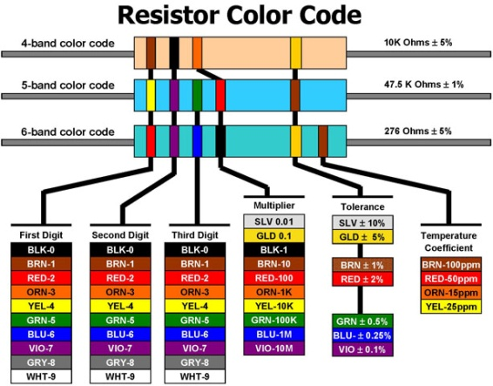

**Figure 1: Procedure to find the value of Resistor using Colour codes**

**Resistor Colour Codes:** Resistors are devices that limit current flow and provide a voltagedrop in electrical circuits. Because carbon resistors are physically small, they are colour-coded to identify their resistance value in Ohms. The use of colon bands on the body of a resistor is the most common system for indicating the value of a resistor. Colour-coding is standardized by the Electronic Industries Association (EIA).

Use the Resistor Colour Code Chart (above) to understand how to use the colour code system. When looking at the chart, note the illustration of three round resistors with numerous colour code bands. The first resistor in the chart (with 4 bands) tells you the minimum information you can learn from a resistor. The next (a 5-band code) provides a little more information about the resistor. The third resistor (a 6-band) provides even more information. Each colour band is associated with a numerical value.

**How to read a typical 4-band, 5-band and 6-band resistor: 4-Band:** Reading theresistor from left to right, the first two colour bands represent *significant digits* , the third band represents the decimal *multiplier*, and the fourth band represents the *tolerance*. **5-Band:** The first three colour bands represent*significant digits*, the fourth band representsthe decimal *multiplier*, and the fifth band represents the *tolerance*. **6-Band:** The first three colour bands represent *significant digits*, the fourth band represents the decimal multiplier, the fifth band represents the tolerance, and the sixth band represents the temperature coefficient.

**Definitions of colour bands:** The colour of the*multiplier*band represents multiples of 10,or the placement of the decimal point. For example: ORANGE (3) represents 10 to the third power or 1,000. The *tolerance* indicates, in a percentage, how much a resistor can vary above or below its value. A gold band stands for +/- 5%, a silver band stands for +/-10%, and if there is no fourth band it is assumed to be +/- 20%. For example: A 100-Ohm 5% resistor can vary from 95 to 105 Ohms and still be considered within the manufactured tolerance. The *temperature coefficient* band specifies the maximum change in resistance with change in temperature, measured in parts per million per degree Centigrade (ppm/°C).

**Example (from chart):** Let’s look at the first resistor on the chart. In this case, the firstcolour band is BROWN. Following the line down the chart you can see that BROWN represents the number 1. This becomes our first *significant digit*. Next, look at the second band and you will see it is BLACK. Once again, follow the line down to the bar scale; it holds a value of 0, our second *significant digit*. Next, look at the third band, the *multiplier*, and you will see it is ORANGE. Once again, follow the line down to the barscale; it holds a value of 3. This represents 3 multiples of 10 or 1000. With this information, the resistance is determined by taking the first two digits, 1 and 0 (10) and multiplying by 1,000. Example: 10 X 1000 = 10,000 or 10,000 Ohms. Using the chart, the fourth band (GOLD), indicates that this resistor has a tolerance of +/- 5%. Thus, the permissible range is: 10,000 X .05 = +/- 500 Ohms, or 9,500 to 10,500 Ohms.

**1.3. TYPES OF RESISTORS**

1. Carbon Resistors
2. Wire wound Resistors

**Carbon Resistors**

There are many types of resistors, both fixed and variable. The most common type for electronics use is the carbon resistor. They are made in different physical sizes with power dissipation limits commonly from 1 watt down to 1/8 watt. The resistance value and tolerance can be determined from the standard resistor [colour code.](http://hyperphysics.phy-astr.gsu.edu/hbase/electronic/rescarb.html#c2)

A variation on the colour code is used for precision resistors which may have five colour bands. In that case the first three bands indicate the first three digits of the resistance value and the fourth band indicates the number of zeros. In the five band code the fifth band is gold for 1% resistors and silver for 2%.

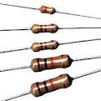

**Figure 2: Images of Carbon Resistors**

**Wire Wound Resistors**

Wire wound resistors are commonly made by winding a metal wire, usually [nichrome,](http://en.wikipedia.org/wiki/Nichrome) around a ceramic, plastic, or fibreglass core. The ends of the wire are soldered or welded to two caps or rings, attached to the ends of the core. The assembly is protected with a layer of paint, moulded plastic, or an [enamel](http://en.wikipedia.org/wiki/Vitreous_enamel) coating baked at high temperature. Because of the very high surface temperature these resistors can withstand temperatures of up to +450 °C.[[6]](http://en.wikipedia.org/wiki/Resistor#cite_note-Vishay08-6) Wire leads in low power wire wound resistors are usually between 0.6 and 0.8 mm in diameter and tinned for ease of soldering. For higher power wire wound resistors, either a ceramic outer case or an aluminium outer case on top of an insulating layer is used. The aluminium-cased types are designed to be attached to a heat sink to dissipate the heat; the rated power is dependent on being used with a suitable heat sink, e.g., a 50 W power rated resistor will overheat at a fraction of the power dissipation if not used with a heat sink. Large wire wound resistors may be rated for 1,000 watts or more.

Because wire wound resistors are [coils](http://en.wikipedia.org/wiki/Electromagnetic_coil) they have more undesirable [inductance](http://en.wikipedia.org/wiki/Electromagnetic_induction) than other types of resistor, although winding the wire in sections with alternately reversed direction can minimize inductance. Other techniques employ [bifilar winding,](http://en.wikipedia.org/wiki/Bifilar_winding) or a flat thin former (to reduce cross-section area of the coil). For the most demanding circuits, resistors with [Ayrton-Perry winding](http://en.wikipedia.org/wiki/Ayrton-Perry_winding) are used.

Applications of wire wound resistors are similar to those of composition resistors with the exception of the high frequency. The high frequency response of wire wound resistors is substantially worse than that of a composition resistor.

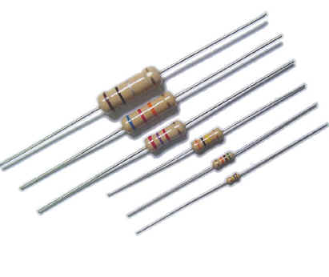

**Figure 3: Images of Carbon Resistors**

**1.4. CAPACITOR**

A **capacitor** (originally known as a **condenser**) is a [passive](http://en.wikipedia.org/wiki/Passivity_%28engineering%29) [two-terminal](http://en.wikipedia.org/wiki/Terminal_%28electronics%29) [electrical](http://en.wikipedia.org/wiki/Electronic_component) [component](http://en.wikipedia.org/wiki/Electronic_component) used to store [energy](http://en.wikipedia.org/wiki/Energy) [electro statically](http://en.wikipedia.org/wiki/Electrostatic) in an [electric field.](http://en.wikipedia.org/wiki/Electric_field) By contrast, [batteries](http://en.wikipedia.org/wiki/Battery_%28electricity%29) store energy via [chemical reactions.](http://en.wikipedia.org/wiki/Chemical_reaction) The forms of practical capacitors vary widely, but all contain at least two [electrical conductors](http://en.wikipedia.org/wiki/Electrical_conductor) separated by a [dielectric](http://en.wikipedia.org/wiki/Dielectric) [(insulator);](http://en.wikipedia.org/wiki/Insulator_%28electricity%29) for example, one common construction consists of metal foils separated by a thin layer of insulating film. Capacitors are widely used as parts of [electrical circuits](http://en.wikipedia.org/wiki/Electrical_circuit) in many common electrical devices.

When there is a [potential difference](http://en.wikipedia.org/wiki/Potential_difference) (voltage) across the conductors, a static [electric field](http://en.wikipedia.org/wiki/Electric_field) develops across the dielectric, causing positive charge to collect on one plate and negative charge on the other plate. [Energy](http://en.wikipedia.org/wiki/Energy) is stored in the electrostatic field. An ideal capacitor is characterized by a single constant value, [capacitance.](http://en.wikipedia.org/wiki/Capacitance)

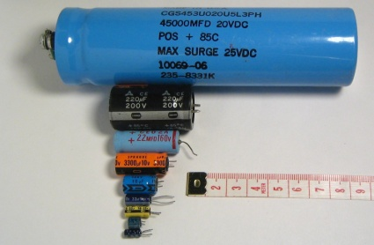

**Figure 4: Electrolytic capacitors of different voltages and capacitance**

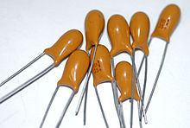

**Figure 5: Solid-body, resin-dipped 10 of 35 V** [**Tantalum capacitors.**](http://en.wikipedia.org/wiki/Tantalum_capacitor)

**1.5. COLOUR CODING OF CAPACITORS**

In general, a capacitor consists of two metal plates insulated from each other by a dielectric. The capacitance of a capacitor depends primarily upon its shape and size and upon the relative permittivity εr of the medium between the plates. One classification of capacitors comes from the physical state of their dielectrics, which may be gas (or vacuum), liquid, solid, or a combination of these. Each of these classifications may be subdivided according to the specific dielectric used. Capacitors may be further classified by their ability to be used in alternating-current (ac) or direct-current (dc) circuits with various current levels.

**Capacitor Identification Codes:** There are no international agreements in place tostandardize capacitor identification. Most plastic film types (Figure1) have printed values and are normally in microfarads or if the symbol is n, Nanofarads. Working voltage is easily identified. Tolerances are upper case letters: M = 20%, K = 10%, J = 5%, H = 2.5% and F = ± 1pF.

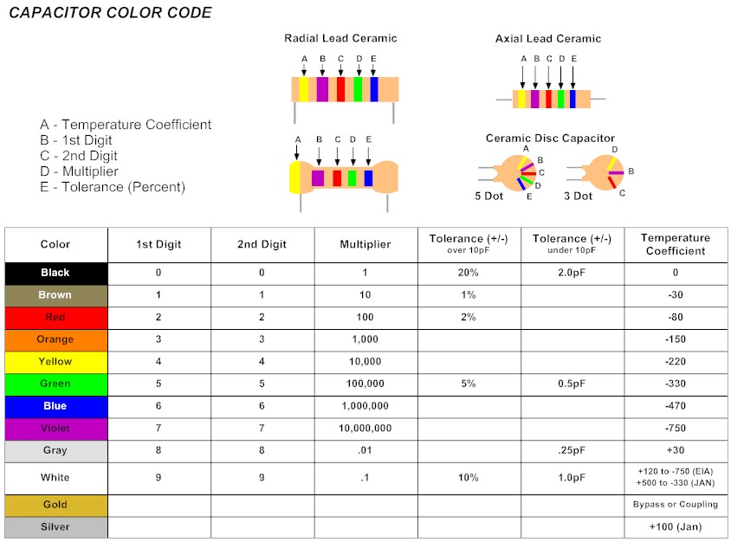

**Figure 6: Colour codes of Capacitor**

**Electrolytic capacitor properties**

There are a number of parameters of importance beyond the basic capacitance and capacitive reactance when using electrolytic capacitors. When designing circuits using electrolytic capacitors it is necessary to take these additional parameters into consideration for some designs, and to be aware of them when using electrolytic capacitors

* **ESR Equivalent series resistance:** Electrolytic capacitors are often used in circuitswhere current levels are relatively high. Also under some circumstances and current sourced from them needs to have low source impedance, for example when the capacitor is being used in a power supply circuit as a reservoir capacitor. Under these conditions it is necessary to consult the manufacturers‟ datasheets to discover whether the electrolytic capacitor chosen will meet the requirements for the circuit. If the ESR is high, then it will not be able to deliver the required amount of current in the circuit, without a voltage drop resulting from the ESR which will be seen as a source resistance.
* **Frequency response:** One of the problems with electrolytic capacitors is that theyhave a limited frequency response. It is found that their ESR rises with frequency and this generally limits their use to frequencies below about 100 kHz. This is particularly true for large capacitors, and even the smaller electrolytic capacitors should not be relied upon at high frequencies. To gain exact details it is necessary to consult the manufacturers data for a given part.
* **Leakage:** Although electrolytic capacitors have much higher levels of capacitancefor a given volume than most other capacitor technologies, they can also have a higher level of leakage. This is not a problem for most applications, such as when they are used in power supplies. However under some circumstances they are not suitable. For example they should not be used around the input circuitry of an operational amplifier. Here even a small amount of leakage can cause problems because of the high input impedance levels of the op-amp. It is also worth noting that the levels of leakage are considerably higher in the reverse direction.
* **Ripple current:** When using electrolytic capacitors in high current applicationssuch as the reservoir capacitor of a power supply, it is necessary to consider the ripple current it is likely to experience. Capacitors have a maximum ripple current they can supply. Above this they can become too hot which will reduce their life. In extreme cases it can cause the capacitor to fail. Accordingly it is necessary to calculate the expected ripple current and check that it is within the manufacturer’s maximum ratings.
* **Tolerance:** Electrolytic capacitors have a very wide tolerance. Typically this may be-50% + 100%. This is not normally a problem in applications such as decoupling or power supply smoothing, etc. However they should not be used in circuits where the exact value is of importance.
* **Polarization:** Unlike many other types of capacitor, electrolytic capacitors arepolarized and must be connected within a circuit so that they only see a voltage across them in a particular way.

The physical appearance of electrolytic capacitor is as shown in Figure 5.The capacitors themselves are marked so that polarity can easily be seen. In addition to this it is common for the can of the capacitor to be connected to the negative terminal.

**Figure 7: Electrolytic capacitor**

It is absolutely necessary to ensure that any electrolytic capacitors are connected within a circuit with the correct polarity. A reverse bias voltage will cause the centre oxide layer forming the dielectric to be destroyed as a result of electrochemical reduction. If this occurs a short circuit will appear and excessive current can cause the capacitor to become very hot. If this occurs the component may leak the electrolyte, but under some circumstances they can explode. As this is not uncommon, it is very wise to take precautions and ensure the capacitor is fitted correctly, especially in applications where high current capability exists.

**1.6. COLOUR CODING OF INDUCTORS**

Inductor is just coil wound which provides more reactance for high frequencies and low reactance for low frequencies. Moulded inductors follow the same scheme except the units are usually micro henries. A brown-black-red inductor is most likely a 1000 uH. Sometimes a silver or gold band is used as a decimal point. So a red-gold-violet inductor would be a 2.7 uH. Also expect to see a wide silver or gold band before the first value band and a thin tolerance band at the end. The typical Colour codes and their values are shown in Figure 7.

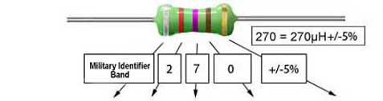

**Figure 8: Typical inductors Colour coding and their values.**

1. **CIRCUIT SYMBOLS**

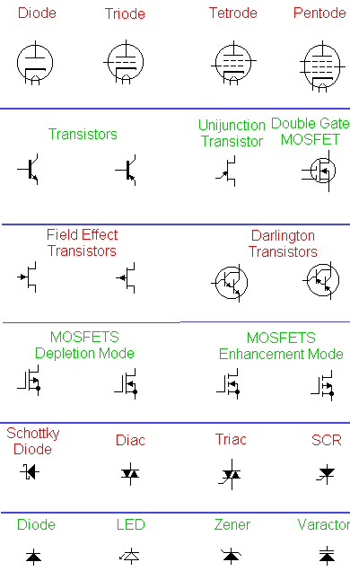

**Figure 9: Circuit Symbols**

**3. i) Study & Operation of Multimeter**

A **Digital multimeter** or **DMM** is test equipment used for resistance, voltage, current measurement and other electrical parameters as per requirement and displaying the results in the mathematical digits form on an LCD or [LED](http://analyseameter.com/2016/03/led-construction-working-principle-bulbs-types.html) readout. It is a type of [multimeter](http://analyseameter.com/2015/08/digital-analog-multimeters-guide.html) which functions digitally. Digital multimeters are widely accepted worldwide as they have better accuracy levels and ranging from simple 3 ½ to 4 ½ digit handheld DMM to very special system DMM.

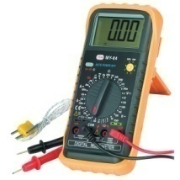

**Figure 10: Digital Multimeter**

**Features of Digital Multimeter**

Digital multimeter is most advanced instruments that make use of modern Integrated circuits for making electrical measurements. Some of its features which make it famous in the eyes of professional technicians are:

1. It is light in weight.
2. Capable of giving more accurate readings.
3. It measures lots of physical quantities like voltage, current, resistance, frequency etc.
4. It is less costly.
5. It measures different electrical parameters at high frequencies with the help of special probes.

**Analog meters** are older designs, but still preferred by many engineers. One reason for this is that analog meters are more sensitive to changes in the circuit that is being measured. A digital multimeter samples the quantity being measured and then displays it. Analog multimeters continuously read the test value. If there are slight changes in readings, the needle of an analog multimeter will track them while digital multimeters may miss them or be difficult to read. This continuous tracking feature becomes important when testing capacitors or coils. A properly functioning capacitor should allow current to flow when voltage is applied, then the current slowly decreases to zero and this "signature" is easy to see on an analog multimeter but not on a digital multimeter.

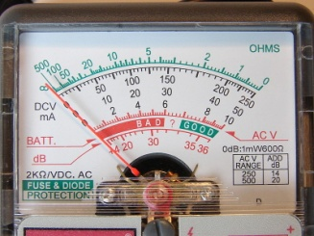

**Figure 11: Analog Multimeter**

**ii) Study & Operation of Function generator**

**A function generator is a signal source that has the capability of producing different types of waveforms as its output signal.**The most common output waveforms are sine-waves, [**triangular waves**](http://www.circuitstoday.com/triangular-wave-generator), [**square waves**](http://www.circuitstoday.com/square-wave-generator-using-op-amp), and [**saw tooth waves**](http://www.circuitstoday.com/sawtooth-wave-generator). The frequencies of such waveforms may be adjusted from a fraction of a hertz to several hundred kHz.

Many function generators are also capable of generating two different waveforms simultaneously (from different output terminals, of course). This can be a useful feature when two generated signals are required for a particular application.

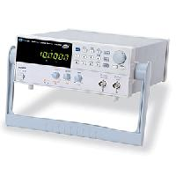

**Figure 12: Function generator**

**iii) Study & Operation of Regulated Power Supply**

Regulated power supply is an electronic circuit that is designed to provide a constant dc voltage of predetermined value across load terminals irrespective of ac mains fluctuations or load variations.

**The quality of the power supply is determined by various characteristics like**load voltage, load current, voltage regulation, source regulation, output impedance, ripple rejection, and so on. Some of the characteristics are briefly explained below:

1. **Load Regulation** – The load regulation or load effect is the change in regulated output voltage when the load current changes from minimum to maximum value.

**Load regulation = Vno-load – Vfull-load**

 Vno-load – Load Voltage at no load

Vfull-load – Load voltage at full load.

From the above equation we can understand that when Vno-load occurs the load resistance is infinite, that is, the out terminals are open circuited. Vfull-load occurs when the load resistance is of the minimum value where voltage regulation is lost.

**% Load Regulation = [(Vno-load – Vfull-load)/Vfull-load] * 100**

2.**Minimum Load Resistance** – The load resistance at which a power supply delivers its full-load rated current at rated voltage is referred to as minimum load resistance.

**Minimum Load Resistance = Vfull-load/Ifull-load**

The value of Ifull-load, full load current should never increase than that mentioned in the data sheet of the power supply.

3. **Source/Line Regulation** – The source regulation is defined as the change in regulated output voltage for a specified rage of line voltage.

4. **Output Impedance** – A regulated power supply is a very stiff dc voltage source. This means that the output resistance is very small. Even though the external load resistance is varied, almost no change is seen in the load voltage. An ideal voltage source has an output impedance of zero.

5. **Ripple Rejection** – Voltage regulators stabilize the output voltage against variations in input voltage. Ripple is equivalent to a periodic variation in the input voltage. Thus, a voltage regulator attenuates the ripple that comes in with the unregulated input voltage. Since a voltage regulator uses negative feedback, the distortion is reduced by the same factor as the gain.

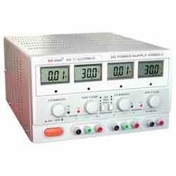

**Figure 13: Regulated Power Supply**

**iv) STUDY OF CRO**

An oscilloscope is a test instrument which allows us to look at the 'shape' of electrical signals by displaying a graph of voltage against time on its screen. It is like a voltmeter with the valuable extra function of showing how the voltage varies with time. A reticule with a 1cm grid enables us to take measurements of voltage and time from the screen.

The graph, usually called the trace, is drawn by a beam of electrons striking the phosphor coating of the screen making it emit light, usually green or blue. This is similar to the way a television picture is produced.

Oscilloscopes contain a vacuum tube with a cathode (negative electrode) at one end to emit electrons and an anode (positive electrode) to accelerate them so they move rapidly down the tube to the screen. This arrangement is called an electron gun. The tube also contains electrodes to deflect the electron beam up/down and left/right.

The electrons are called cathode rays because they are emitted by the cathode and this gives the oscilloscope its full name of cathode ray oscilloscope or CRO.

A dual trace oscilloscope can display two traces on the screen, allowing us to easily compare the input and output of an amplifier for example. It is well worth paying the modest extra cost to have this facility.

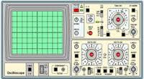

**Figure 14: Cathode Ray Oscilloscope**

**Experiment-1**

**FULL WAVE RECTIFIER WITH & WITHOUT FILTER**

**Aim:**

1. To plot Output waveform of the Full Wave Rectifier.
2. To find ripple factor for Full Wave Rectifier using the formulae.
3. To find the efficiency, Vp(rect), Vdc for Full Wave Rectifier.

**Apparatus:**

|  |  |  |  |  |
| --- | --- | --- | --- | --- |
| **S. No** | **Apparatus** | **Type** | **Range** | **Quantity** |
| 01 | Transformer |  | 6-0-6 V | 1 |
| 02 | Resistance |  | 1K ohm | 1 |
| 03 | Capacitor |  | 100µ F | 1 |
| 04 | Diode | IN4007 |  | 2 |
| 05 | Bread board and connecting wires |  |  |  |

**Theory:**

The circuit of a center-tapped full wave rectifier uses two diodes D1&D2. During positive half cycle of secondary voltage (input voltage), the diode D1 is forward biased and D2is reverse biased. So the diode D1 conducts and current flows through load resistor RL.

During negative half cycle, diode D2 becomes forward biased and D1 reverse biased. Now, D2 conducts and current flows through the load resistor RL in the same direction. There is a continuous current flow through the load resistor RL, during both the half cycles and will get unidirectional current as show in the model graph. The difference between full wave and half wave rectification is that a full wave rectifier allows unidirectional (one way) current to the load during the entire 360 degrees of the input signal and half-wave rectifier allows this only during one half cycle (180 degree).

**THEORITICAL CALCULATIONS:**

Vrms = Vm/ √2

Vm =Vrms√2

Vdc=2Vm/П

(**i)Without filter**:Ripple factor, r = √ (Vrms/ Vdc )2 -1 = 0.812

**(ii)With filter**:Ripple factor, r = 1/ (4√3 f C RL)

**Circuit Diagram:**

**Full wave rectifier without Filter:**



**Full wave rectifier with Filter:**



**Procedure:**

1. Connections are made as per the circuit diagram.
2. Connect the ac mains to the primary side of the transformer and the secondary side to the rectifier.
3. Measure the ac voltage at the input side of the rectifier.
4. Measure both ac and dc voltages at the output side the rectifier.
5. Find the theoretical value of the dc voltage by using the formula Vdc=2Vm/П
6. Connect the filter capacitor across the load resistor and measure the values of Vac and Vdc at the output.
7. The theoretical values of Ripple factors with and without capacitor are calculated.
8. From the values of Vac and Vdc practical values of Ripple factors are calculated. The practical values are compared with theoretical values.

**Procedure Without Filter**

1. Give the connections as per the circuit diagram.

2. Give 230 V, 50Hz Input to the stepdown transformer where secondary connected to the rectifier input.

3. Measure the rectifier output across the load.

4. Plot its performance graph.

**With Filter**

1. Give the connections as per the circuit diagram.

2. Give 230 V, 50Hz Input to the stepdown Transformer where secondary connected to the Rectifier input.

3. Connect the Capacitor across the load.

4. Measure the rectifier output across the load. 5. Plot its performance graph.

**Expected Waveforms:**

**Input Waveform:**



**Output waveform without Filter:**



**Output waveform with filter:**



**Observations:**

|  |  |  |  |  |
| --- | --- | --- | --- | --- |
| **Name condition** | **Vac** | **Vdc** | **Iac** | **Idc** |
| **Without Filter** |  |  |  |  |
| **With Filter** |  |  |  |  |

Formulae :

Full wave Rectifier without Filter

1. Vrms = Vm / √2
2. (ii) Vdc = 2Vm / π
3. (iii) Ripple Factor = √ ((Vrms / Vdc) 2 – 1)
4. (iv) % Efficiency = (Vdc / Vrms) 2 x 100 %

With Filter

1. Vrms = Vrpp /(2*√ 3)
2. Vdc = Vm – V rpp
3. Ripple Factor = Vrms’/ Vdc

**Calculations:**

**Without Filter:**

Iac=Vac/RL=

Idc=Vdc/RL=

**Efficiency:** Vac/Vdc=

**With Filter:**

Iac=Vac/RL=3.1/1K=

Idc=Vdc/RL=3.3/1K=

**Efficiency:** Vac/Vdc=

**Precautions:**

1. The primary and secondary side of the transformer should be carefully identified.
2. The polarities of all the diodes should be carefully identified.

**RESULT:** The ripple factors for Full wave Rectifier with and without load and the loadregulation has been calculated**.**

**Pre Lab Questions**

1. What is the necessity of rectifier?
2. What is PIV of a diode in FWR and HWR?
3. What is ripple factor? Why it is required?
4. Why are filters connected at the output of rectifiers?
5. What are the types of filters used in rectifier? And which is better and why?

**Post Lab Questions**

1. What is TUF?

2. Mention the value of ripple factor for HWR, FWR & rectifier with centre tapped transformer.

3. What is the difference between uncontrolled rectifier and controlled rectifier? Which is advantageous and why?

4. State the average and peak value of output voltage and current for full wave rectifier and half wave rectifier.

5. What is PIV of a diode in half wave and full wave rectifier?

**EXPERIMENT-2**

**COMMON EMITTER CONFIGURATION CHARACTERISTICS**

**Aim:**

To study the input and output characteristics of a bipolar junction transistor in common emitter configuration.

**Apparatus:**

|  |  |  |  |  |
| --- | --- | --- | --- | --- |
| **S. No** | **Apparatus** | **Type** | **Range** | **Quantity** |
|  |  |  |  |  |
| 01 | transistor | BC107 |  | 1 |
|  |  |  |  |  |
| 02 | Resistance |  | 1k ohm | 2 |
|  |  |  |  |  |
| 03 | Regulated power supply |  | (0 – 30V) | 1 |
|  |  |  |  |  |
| 04 | Ammeter | mC | (0-20)mA | 2 |
|  |  |  |  |  |
| 05 | Voltmeter | mC | (0 – 20)V | 2 |
| 06 | Bread Board & Connecting Wires |  |  |  |

**Theory:**

In common emitter configuration, input voltage is applied between base and emitter terminals and output is taken across the collector and emitter terminals. Therefore the emitter terminal is common to both input and output.

The input characteristics resemble that of a forward biased diode curve. This is expected since the Base-Emitter junction of the transistor is forward biased. As compared to CB arrangement IB increases less rapidly with VBE. Therefore input resistance of CE circuit is higher than that of CB circuit. The output characteristics are drawn between Ic and VCE at constant IB. the collector current varies with VCE upto few volts only. After this the collector current becomes almost constant, and independent of VCE. The value of VCE up to which the collector current changes with V CE is known as Knee voltage. The transistor always operated in the region above Knee voltage, IC is always constant and is approximately equal to IB.The current amplification factor of CE configuration is given by

|  |  |  |  |
| --- | --- | --- | --- |
| β = ΔIC/ΔIB |  |  |  |
| Input Resistance, ri | = | **∆VBE /∆IB (**μA) | at Constant VCE |
| Output Résistance, ro | = | **∆VCE /∆IC** | at Constant IB (μA) |

**Circuit Diagram:**



**Procedure:**

**A). Input Characteristics:**

1. Connect the transistor in CE configuration as per circuit diagram
2. Keep output voltage VCE = 0V by varying VCC.
3. Varying VBB gradually, note down both base current IB and base - emitter voltage (VBE).
4. Repeat above procedure (step 3) for various values of VCE

**B). Output Characteristics:**

1. Make the connections as per circuit diagram.
2. By varying VBB keep the base current I B = 20µ A.
3. Varying VCC gradually, note down the readings of collector-current (IC) and collector- emitter voltage (VCE).
4. Repeat above procedure (step 3) for different values of IE

**Observations:**

**A). Input Characteristics:**

|  |  |  |  |  |
| --- | --- | --- | --- | --- |
| **VBB(V)** | **VCE=-0V** | | **VCE=4V** | |
| **VEB(V)** | **IE(mA)** | **VEB(V)** | **IE(mA)** |
|  |  |  |  |  |

**A). Output Characteristics:**

|  |  |  |  |  |
| --- | --- | --- | --- | --- |
| **VCC(V)** | **IB=50μA** | | **IB=60μA** | |
| **VCE(V)** | **IC(mA)** | **VCE(V)** | **IC(mA)** |
|  |  |  |  |  |

**Expected Graph:**

**A). Input Characteristics:**



**B). Output characteristics:**



**Calculations from graph:**

**1. Input resistance:**

To obtain input resistance find ∆VBE and ∆IB at constant VCE on one of the input characteristics.

Then Ri = ∆VBE / ∆IB (VCE constant)=

**2. Output resistance:** To obtain output resistance, find ∆IC and ∆VCE at constant IB.

Ro = ∆VCE / ∆IC (IB constant)=

**Calculations from graph:**

1. Input impedance (hic)= = ∆VBE / ∆IB , VCE constant.
2. Forward current gain(hfc)= = ∆Ic / ∆IB , VCE constant
3. Output admittance(hoe)= = ∆Ic / ∆ VEC , IB constant
4. Reverse voltage gain(hrc)= ∆VBE/∆ VEC , IB constant

**Precautions:**

1. While doing the experiment do not exceed the ratings of the transistor. This may lead to damage the transistor.
2. Connect voltmeter and Ammeter in correct polarities as shown in the circuit diagram.
3. Do not switch **ON** the power supply unless you have checked the circuit connections as per the circuit diagram.
4. Make sure while selecting the emitter, base and collector terminals of the transistor.

**Result:** Thus the input and output characteristics of CE configuration is plotted.

1. Input Resistance (Ri) = ……………Ω
2. Output Resistance (Ro) = ……………Ω

**EXPERIMENT 3**

**COMMON BASE CONFIGURATION CHARACTERISTICS**

**Aim:**

1. To observe and draw the input and output characteristics of a transistorconnected in common base configuration.
2. To find α of the given transistor and also its input and output resistances.

**Apparatus:**

|  |  |  |  |  |
| --- | --- | --- | --- | --- |
| **S. No** | **Apparatus** | **Type** | **Range** | **Quantity** |
|  |  |  |  |  |
| 01 | transistor | BC107 |  | 1 |
|  |  |  |  |  |
| 02 | Resistance |  | 1k ohm | 2 |
|  |  |  |  |  |
| 03 | Regulated power supply |  | (0 – 30V) | 1 |
|  |  |  |  |  |
| 04 | Ammeter | mC | (0-20)mA | 2 |
|  |  |  |  |  |
| 05 | Voltmeter | mC | (0 – 20)V | 2 |
| 06 | Bread Board & Connecting Wires |  |  |  |

**Theory:**

A transistor is a three terminal active device. The terminals are emitter, base, collector. In CB configuration, the base is common to both input (emitter) and output (collector). For normal operation, the E-B junction is forward biased and C-B junction is reverse biased. In CB configuration, IE is +ve, IC is –ve and IB is –ve. So,

**VEB = F1 (VCB, IE) and IC = F2 (VEB,IB)**

With an increasing the reverse collector voltage, the space-charge width at the output junction increases and the effective base width „W‟ decreases. This phenomenon is known as “Early effect”. Then, there will be less chance for recombination within the base region. With increase of charge gradient with in the base region, the current of minority carriers injected across the emitter junction increases. The current amplification factor of CB configuration is given by,

|  |  |  |  |
| --- | --- | --- | --- |
| **α = ∆IC/ ∆IE** | |  |  |
| Input Resistance, ri | = | **∆VBE /∆IE** | at Constant VCB |
| Output Résistance, ro | = | **∆VCB /∆IC** | at Constant IE |

**Circuit Diagram:**



**Procedure:**

1. **Input characteristics:**
   1. Connections are made as per the circuit diagram.
   2. For plotting the input characteristics, the output voltage VCE is kept constant at 0V and for different values of VEE ,note down the values of IE and VBE
   3. Repeat the above step keeping VCB at 2V, 4V, and 6V and all the readings are tabulated.
   4. A graph is drawn between VEB and IE for constant VCB.
2. **Output characteristics:**
   1. Connections are made as per the circuit diagram.
   2. For plotting the output characteristics, the input IE is kept constant at 0.5mA and for different values of VCC, note down the values of IC and VCB.
   3. Repeat the above step for the values of IE at 1mA, 5mA and all the readings are tabulated.
   4. A graph is drawn between VCB and Ic for constant IE

**Observations:**

**A). Input Characteristics:**

|  |  |  |  |  |  |
| --- | --- | --- | --- | --- | --- |
| **VCB=0V** | | **VCB=2V** | | **VCB=4V** | |
| **VEB(V)** | **IE(mA)** | **VEB(V)** | **IE(mA)** | **VEB(V)** | **IE(mA)** |
|  |  |  |  |  |  |

**B). Output Characteristics:**

|  |  |  |  |  |  |
| --- | --- | --- | --- | --- | --- |
| **IE=-5mA** | | **IE=-10mA** | | **IE=-20mA** | |
| **VCB(V)** | **IC(mA)** | **VCB(V)** | **IC(mA)** | **VCB(V)** | **IC(mA)** |
|  |  |  |  |  |  |

**Expected Graph:**

**A). Input characteristics:**



**B). Output Characteristics:**



**Calculations from graph:**

1. Input impedance(hic)= = ∆VEB / ∆IE ==
2. Forward current gain(hfc)= = ∆IC / ∆IE==
3. Output admittance(hoc)= = ∆IC / ∆ VCB==
4. Reverse voltage gain(hrc)= VEB/ VBC==

**Precautions:**

1. The supply voltages should not exceed the rating of the transistor.
2. Meters should be connected properly according to their polarities.

**Result:** Thus the input and output characteristics of CC configuration are plotted and h parameters are found.

**Experiment-4**

**Common Source amplifier Characteristics**

**OBJECTIVE:** 1. To obtain the frequency response of the Common Source FET Amplifier

2. To find the Bandwidth.

## APPRATUS:

MULTISIM 2001 SOFTWARE PC

## CIRCUIT DIAGRAM:

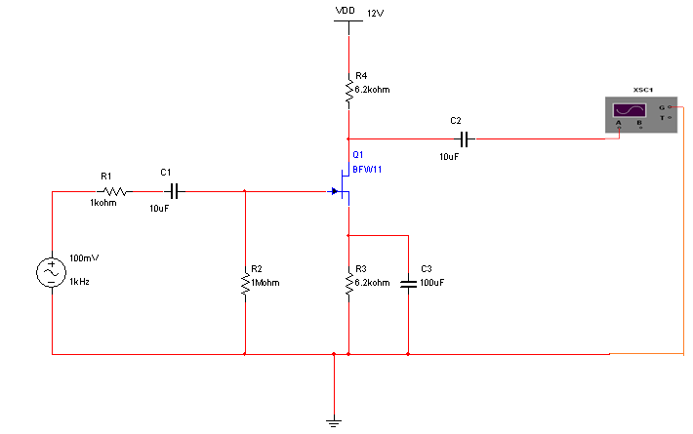

**THEORY**:

A field-effect transistor (FET) is a type of transistor commonly used for weak-signal amplification (for example, for amplifying wireless (signals)). The device can amplify analog or digital signals. It can also switch DC or function as an oscillator. In the FET, current flows along a semiconductor path called the *channel.* At one end of the channel, there is an electrode called the *source*. At the other end of the channel, there is an electrode called the *drain*. The physical diameter of the channel is fixed, but its effective electrical diameter can be varied by the application of a voltage to a control electrode called the *gate.* Field-effect transistors exist in two major classifications. These are known as the *junction FET (JFET) and the metal-oxide-semiconductor FET (MOSFET).* The junction FET has a channel consisting of N-type semiconductor (N-channel) or P-type semiconductor (P-channel) material; the gate is made of the opposite semiconductor type. In P-type material, electric charges are carried mainly in the form of electron deficiencies called *holes*. In N-type material, the charge carriers are primarily electrons. In a JFET, the junction is the boundary between the channel and the gate. Normally, this P-N junction is reverse-biased (a DC voltage is applied to it) so that no current flows between the channel and the gate. However, under some conditions there is a small current through the junction during part of the input signal cycle. The FET has some advantages and some disadvantages relative to the bipolar transistor. Field-effect transistors are preferred for weak-signal work, for example in wireless, communications and broadcast receivers. They are also preferred in circuits and systems requiring high impedance. The FET is not, in general, used for high-power amplification, such as is required in large wireless communications and broadcast transmitters.

Field-effect transistors are fabricated onto silicon integrated circuit (IC) chips. A single IC can contain many thousands of FETs, along with other components such as resistors, capacitors, and diodes.

## PROCEDURE:

* 1. Start MULTISIM. A blank circuit window will appear on the screen along with a component tool bar.
  2. Using component tool bar place all the components on the circuit window and wire the circuit.
  3. A sinusoidal signal of 1 KHz frequency and 200mV peak-to-peak is applied at the input of amplifier.
  4. Output is taken at drain and gain is calculated by using the expression,

Av=V0/Vi

* 1. Voltage gain in dB is calculated by using the expression,

Av=20log 10(V0/Vi)

* 1. Repeat the above steps for different frequencies.
  2. For plotting the frequency response the input voltage is kept Constant at 50mV peak-to- peak and the frequency is varied from 10Hz to 1MHz using AC Voltage Source.
  3. The Bandwidth of the amplifier is calculated from the graph using the
  4. Expression,

Bandwidth BW=f2-f1 Where f1 is lower 3 dB frequency f2 is upper 3 dB frequency

## OBSERVATIONS:

**Input Voltage given Vin:50mV**

|  |  |  |  |
| --- | --- | --- | --- |
| **Frequency(Hz)** | **Output Voltage (Vo)** | **Gain= Vo/Vin** | **Av in dB**  **20 log (Vo/Vin)** |
| 10  50  100  200  400  600  800  1K  5K  10K  50K  100K  200K  400K  600K  800K  1M |  |  |  |

**MODEL GRAPH:**

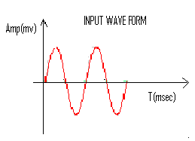

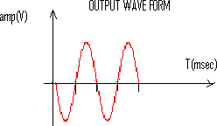

**FREQUENCY RESPONSE:**

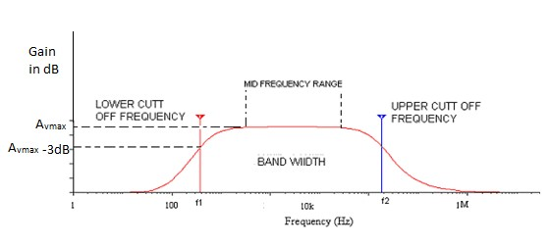

**PRECAUTIONS**

1. All the connections are to be connected properly.
2. Transistor terminals must be identified properly

**RESULT**: The frequency response of the common source FET Amplifier and Bandwidth is obtained.

**LEARNING OUTCOMES:**

Students are able to

* 1. Design and analyze CE amplifier using MULTISIM software.
  2. Calculate voltage gain and bandwidth of CE amplifier from the observations made.

## VIVA QUESTIONS

1. What are the differences between FET and BJT?
2. Is FET an unipolar or bipolar device ?
3. Draw the symbol of FET?
4. What are the applications of FET?
5. Is FET a voltage controlled or current controlled device?
6. Draw the equivalent circuit of common source FET amplifier?
7. What is the voltage gain of the FET amplifier?
8. What is the input impedance of FET amplifier?
9. What is the output impedance of FET amplifier?
10. What are the FET parameters?